

*“Tinman Portrait”* by [Josh Guglielmo | Personal Work — Arcane Chroma](http://www.arcanechroma.com/personal-work)

When awaking: “[Calibrating Sensors](https://youtu.be/eIas_87wTg4?t=256)”

Is a steam calliope.

“I was once part of a fairground before being bought by a savy inventor. They gave me life and delegated me to the lowly jobs of a server. I followed my assignments well, but longed for more. One day, I was stolen and heavily damaged, but through the use of the skills I had picked up from watching the inventor work, i was able to repair myself (and add a couple of upgrades). When I returned to my master, they set me free on the grounds that they knew I could achieve greatness! So I setout to pursue my dream of being… an entertainer!” *Off-key calliope music*.

“Oh! HE-1, “*tinman*”! Yeah I remember him.. Pet project of mine, was suppose to just play the piano and do the chores, but I guess I got a bit carried away with the possibilities and well… he went rogue. Found him about a month later, poor guy had been attacked by some of the youths who thought what I was doing was “inhumane” I mean he’s not even human for [GOD]’s sake! Oh, sorry, I mean to say: he’s not even alive! Anyway, by the time I found him, his ancient programming had been altered and was heavily damaged - oh! I spoke to their parents later and presumably they were trying to set him free, imagine that! - poor guy managed to crawl away from them and had repaired himself with an old fairground calliope.

Use a reaction to cast a cantrip on an arrow shot by the ranger.

Use reaction to boost rogue’s jump

Bagworm/Bogarts

Deploration

Pasific

Advanced

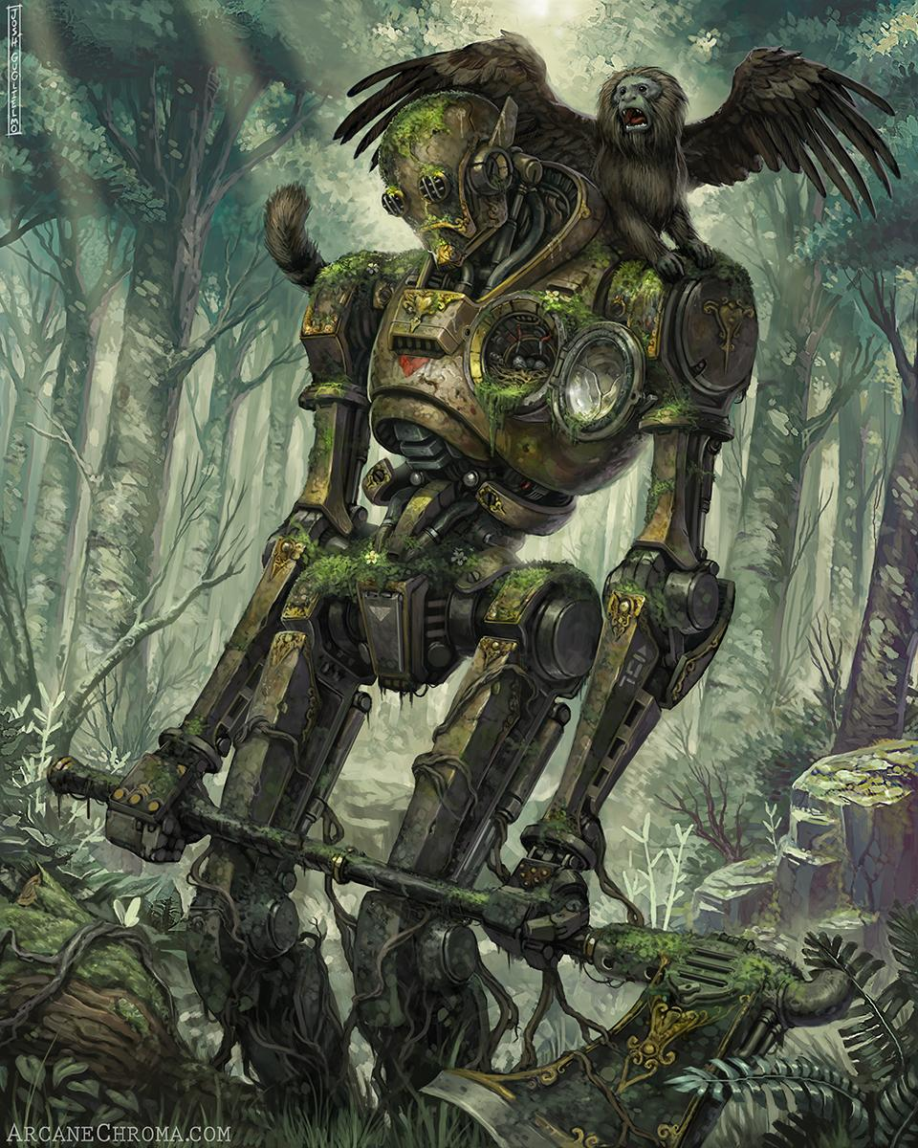

Robotic Parrot Gondolier

[Out of Tune Calliope @ Mayor's Xmas Parade in Baltimore](https://youtu.be/hYATR7REK9U)

[Steam Calliope at Dogwood Parade](https://youtu.be/mGARSl6rW8Y)

[Getz's Steam Calliope at Central PA Ragtime Festival](https://youtu.be/4TRh3hcyNOM)

[Seriously Out-of-Tune Calliope](https://youtu.be/uENUEDMdgv8)